

Project Initialization and Planning Phase

|  |  |
| --- | --- |
| Date | 15 August 2024 |
| Team ID | LTVIP2024TMID24828 |
| Project Name | Fake news analysis in social media |
| Maximum Marks | 3 Marks |

**Define Problem Statements (Customer Problem Statement Template):**

The rise of social media as a primary source of news has led to an alarming increase in the spread of fake news, which can distort public opinion, fuel misinformation, and create social and political unrest. Due to the sheer volume and speed of content generation, identifying and curbing the spread of fake news is a challenging task. Existing manual fact-checking processes are often too slow and inefficient to handle the dynamic nature of online information, necessitating an automated and scalable approach to detect and analyze fake news effectively.

**The user** in the age of digital communication, social media platforms have become primary sources of news for millions. However, the rapid spread of misinformation and fake news poses significant challenges to public discourse, societal trust, and informed decision-making. This project aims to develop a comprehensive analysis system that identifies, classifies, and mitigates the impact of fake news on social media..

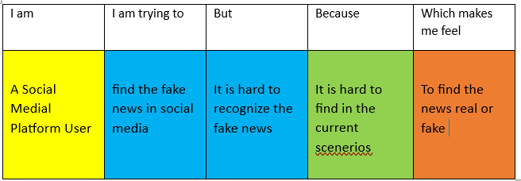

**Problem Statement(PS)**

